

MASENO UNIVERSITY

SCHOOL OF COMPUTING AND INFORMATICS

**DEPARTMENT OF INFORMATION TECHNOLOGY**

**PHARMACY MANAGEMENT SYSTEM**

**CIT 309: GROUP PROJECT**

**PROJECT PROPOSAL SUBMITTED TO THE SCHOOL OF COMPUTING AND INFORMATICS IN PARTIAL FULFILMENT OF THE REQUIREMENTS FOR AWARD OF THE DEGREE OF BACHELOR OF SCIENCE IN INFORMATION TECHNOLOGY**

**MARCH, 2022**

**MASENO UNIVERSITY**

**P.O. BOX PRIVATE BAG**

**MASENO, KENYA**

# **DECLARATION**

We certify that this project proposal is our original work and all material herein that is not our work has been identified. We further certify that no material herein has previously been submitted and approved for the award of any degree, or any other award, by this or any other university.

|  |  |  |
| --- | --- | --- |
| **ADM NO.** | **NAMES** | **SIGNATURE** |
| **CIT/00159/019** | **MALON KIPLETING** |  |
| **CIT/00143/019** | **FRANKLIN ORIGA** |  |
| **CIT/00144/019** | **STEPHEN GAKONYO** |  |

This project proposal has been submitted for examination with my approval as the university supervisor.

--------------------------------------------------- ------------------------------------

**Name of supervisor Date**

**Maseno University**

# DEDICATION

This project proposal is dedicated to our parents, lecturers, and colleagues whose love, understanding, guidance, and encouragement have made it a success. We also dedicate this project proposal to the School of Computing, Maseno University for their ultimate sacrifice to ensure that we have the hands-on skills required in the real world.

# ACKNOWLEDGEMENT

We would like to express our sincere gratitude to our supervisor Mr. James Chamwama for providing his guidance, comments, and suggestions throughout the course of this project.

# **ABSTRACT**

One of the most important responsibilities of pharmacy management is to ensure a continuous supply of drugs and medicines to their customers who are in high demand for them. Each of these functions is critical to the pharmacy's operation hence require an efficient secure records management system, to support evidence based decision making for the pharmacists. This project addresses challenges associated with inventory and related drug information management. It purposes to provide seamless means to generate timely reporting that provides for transparency and accountability in daily transactions in a typical pharmacy. Interviews and questionnaires will be used as primary methods of data collection. The project will ensure improved performance and efficiency in any given pharmacy shop.

# TABLE OF CONTENTS

Table of Contents

PHARMACY MANAGEMENT SYSTEM i

DECLARATION i

DEDICATION ii

ACKNOWLEDGEMENT iii

ABSTRACT iv

TABLE OF CONTENTS v

LIST OF TABLES vii

CHAPTER ONE: INTRODUCTION 9

**1.1 Background to the Study** 9

**1.2 Problem Statement** 9

**1.3 Project objectives** 9

**1.3.1 Main objective** 9

**1.3.2 Specific Objectives** 9

**1.4 Research Questions** 10

**1.5 Significance** 10

**1.6 Scope and limitations** 10

**1.7 Assumptions** 10

CHAPTER TWO: LITERATURE REVIEW 11

**2.1 Introduction** 11

**2.2 Theory guiding the project** 11

**2.3 Medicine management** 12

**2.4 Pharmacy inventory management system** 12

**2.5 Sales and inventory monitoring system** 12

**2.6 Pharmacies in Kenya** 13

**2.6.1 MYDAWA.com** 13

**2.6.2 Goodlife pharmacy** 13

**2.7 Inventory** 13

**2.8 Conclusions** 14

CHAPTER THREE: METHODOLOGY 15

**3.1 Introduction** 15

**3.2 Research design** 15

**3.3 Target population** 15

**3.4 Sample size** 15

**3.5 Choice of Proposed System Development Methodology** 15

**3.6 Systems Analysis, Design, and Development** 16

**3.6.1 Prototype Design modelling tools** 16

**3.6.2 Requirements gathering and analysis** 16

**3.7 Systems Development** 17

**3.7.1 Approach** 17

**3.7.2 Resources** 17

**3.7.3 Hardware and software tools** 18

**3.8 System Testing and Validation** 18

CHAPTER FOUR: SYSTEM PLANNING 20

**4.1 Introduction** 20

**4.2 System study** 20

**4.3 Feasibility analysis** 20

**4.4.1 Technical feasibility** 20

**4.4.2 Economic feasibility** 20

**4.5 Requirement specifications** 20

**4.5.1 User requirements** 20

**4.5.2 Functional requirements** 21

CHAPTER FIVE: SYSTEM ANALYSIS 22

**5.1 Introduction** 22

**5.2 Data and Documents Flow** 22

**5.2.1 Data Flow Diagrams for the Order Processing** 22

**5.3 Requirements analysis** 24

**5.3.1 Hardware and Software Requirements** 24

**5.3.2 User and Security Requirements** 25

**5.3.3 Functional and Non-functional Requirements** 25

**5.4 System and Software Design** 25

**5.4.1 Physical System Design** 26

**5.4.1.1 Entity Relationship Diagram** 26

**5.4.3 Logical Design** 27

**5.5 Conclusion** 31

CHAPTER SIX: SYSTEM DESIGN 32

**6.1 Analysis** 32

**6.2 Presentation of the System** 32

**6.2.2 Database** 33

**6.3 Evaluation of alternatives and strategies** 33

CHAPTER SEVEN: SYSTEMS IMPLEMENTATION 34

**7.1 Systems implementation** 34

**7.2 Systems implementation** 34

**7.2.1 Systems implementation** 34

**7.2.2 Unit testing** 34

**7.2.3 Integration testing** 34

**7.2.3 Acceptance testing** 34

**7.2.4 Acceptance testing** 35

CHAPTER EIGHT: DISCUSSIONS, CONCLUSIONS AND RECOMMENDATIONS 36

**8.1 Introduction** 36

**8.2 Discussions** 36

**8.3 Recommendations** 36

References 38

APPENDIX A: Pharmacy owner sample Questionnaire 39

APPENDIX B: Customers Questionnaire 39

APPENDIX C: Staff Questionnaire 40

APPENDIX D: Sample pharmacy owner Interview Questions 40

APPENDIX E: Sample Customer Interview Questions 40

APPENDIX F: Sample Staff Interview Questions 40

GANTT CHART 41

# LIST OF TABLES

**Table 1 Hardware requirements** 18

**Table 2 Software requirements** 18

# CHAPTER ONE: INTRODUCTION

## **1.1 Background to the Study**

Today’s organizations value efficiency and reliability in terms of delivery and management of their products. Manual systems are far-reaching negative effects which are time-consuming as the staff does not have prior knowledge of available stock levels in the store hence being unable to predict proper timing for new stock deliveries. The management is not in a good position to monitor the profits, trends of growth, losses, and develop strategies to be put in place for the future, due to inconsistencies of manual record-keeping systems. This project will involve the design and implementation of a computerized stock control system. This is a system that will allow an easy and effective way to control and maintain business processes. Losses will be minimized on account of obsolescence due to overstocking. When reorder levels are reached, the system will then automatically place an order to the supplier informing him/her to supply the required product and in the required quantity (Predetermined reorder quantity). Minimum stock levels will be maintained automatically making sure that items are available in the store where and when needed. This project work will prompt the pharmacist about drugs that are close to expiry, preventing those drugs from being sold and also providing a solution to the earlier stated problems.

The system is intended to run in a networked environment so information will be shared efficiently hence reducing the time wasted by moving from one place to another.

## **1.2 Problem Statement**

Managing a very large pharmacy with records on paper is tedious and difficult to keep track of inventories with regards to the drugs in the store, expiry date, quantity of drugs available based on the categories and their functions.

## **1.3 Project objectives**

### **1.3.1 Main objective**

To design, develop and implement a digital pharmacy management system

### **1.3.2 Specific Objectives**

1. To identify requirements for the proposed pharmacy management system.
2. To review the existing literature of the proposed pharmacy management system.
3. To design a computerized pharmacy management system for use at the pharmacies.

4. To test the prototype pharmacy management system.

## **1.4 Research Questions**

1. What are the requirements for the proposed prototype?
2. What understanding exists about the proposed pharmacy management system?
3. What is the best approach to design and development of the pharmacy management system?
4. What tests can validate the performance of the developed prototype?

## **1.5 Significance**

The benefits arising from this project will go along in reshaping the flow of stock in the pharmacy which relies heavily on strategic efficiency initiatives and reliability. The project will help to strategize and harmonize the stock management structure. This will make it easier to manage as well as improving the standard of services offered to customers. It will as well create a prototype that aims to prove the concept of the use of technology in handling pharmacies.

## **1.6** **Scope and limitations**

The project will only address the stock control activities and business processes like maintaining stock levels and automatic placement of orders which will involve store management as the major areas of concern. However, the project will also be confined to the crucial stages of the system development life cycle which will include planning, analysis, design, and implementation of a computerized stock control system.

## **1.7 Assumptions**

* Other aspects of pharmacy management such as personnel management, accounts shall not be addressed in this project.

# CHAPTER TWO: LITERATURE REVIEW

## **2.1 Introduction**

This chapter includes a review of local and foreign-related literature that can help in gathering valuable data and ideas which can guide the development of the proposed pharmacy management system prototype. It gives an overview of the different study that has been done before and the proponents collect some ideas from another study to formulate a new concept to apply when developing the proposed prototype.

## **2.2 Theory guiding the project**

According to the national coordinating counsel for the medication (2019), a medication error is any preventable event that may cause or lead to inappropriate medication use or patient harm while the medication is in the control of the healthcare professional. Recommended steps include developing procedures to assist pharmacists in detecting errors and encouraging hospitals to use error reduction techniques. A frequently recommended method for preventing adverse drug events is Computer-Aided Screening of prescriptions. Pharmacists generally screen or perform a prospective review of a patient's medication regimen during the prescription dispensing process to prevent drug-related problems that, if not corrected, might lead to adverse effects. Prospective Drug Utilization Review became legally mandated for medical patients following the implementation of the Omnibus Budget Reconciliation Act of 1990(OBRA '90) in January 1993. Up to until that time, this activity had been voluntary on the part of the pharmacist (Susan 2008). In performing PDUR, most pharmacists are assisted by DUR software applications that are resident on their pharmacies' computer systems. A pharmacy claims processor may also use DUR software applications online at the time of electronic claims adjudication (Elizabeth 2008). They allow users to review a prescription against a profile of all medications a patient has purchased from all the pharmacies that have submitted prescription claims for that patient and so easier for an organization to compile evidence against the defendant. This data is also vital to users of in-store systems in minimizing medical errors as well as assumptions made from lack of prompt information on the progress of the pharmacy, e.g., the available stock levels to know when to purchase more stock and also records drugs that have been prescribed to the client.

## **2.3 Medicine management**

According to (McPherson, Counahan, & Julie, 2015) , medicines management is the entire process of how medicines are selected, procured, delivered, prescribed, administered, and reviewed to optimize the contribution they make to producing informed and desired outcomes of patient care. In the Philippines, medicine management occurs at levels of government and is different during emergency and non-emergency times. Health services delivery in the Philippines has been repeatedly disrupted as a result of disasters and emergencies – particularly so after Typhoon Haiyan in November 2013. The objectives of this study were to document existing policies for medication management in the Philippines during an emergency and non-emergency periods and to access the public sector medicine management in Haiyan, the affected area during the response.

## **2.4 Pharmacy inventory management system**

According to (Muallem, Assaf, & Dogother, 2015), the preliminary findings of the implementation process of a pharmacy inventory management system at a local Saudi hospital. Preliminary findings show that the implementation process of the pharmacy inventory management system needs the involvement and support of senior management and experienced technical expertise. Future research will focus on investigating the impacts of the pharmacy inventory management system on workflow and medication errors.

## **2.5 Sales and inventory monitoring system**

According to ( JeonSoft Corporation, 2014), an inventory system aims to provide an easier and faster way to monitor the movement of the business's stock of goods. It is interactively designed to possibly do the common tasks done customarily. From item entry, releasing of items, inventory adjustment, transferring of goods from one warehouse to another, and production, sure you can keep track of your inventory. A sales and inventory monitoring system collect data to aid in production scheduling, accurate details, and reliable information. For example, some systems use recent sales data to forecast how many of a type of product will be needed to meet consumer demand shortly. This includes monitoring the levels of a product at all locations The similarities of the proposed system to the Sales and Inventory Monitoring System are almost the same in terms of an automated system, connectivity, platforms (Android or PC), and point of sale.

## **2.6 Pharmacies in Kenya**

Most pharmacies in Kenya have not fully integrated the use of technology in managing their day to day activities. The few which have integrated are inefficient and unreliable. Therefor customers end up seeking private healthcare.

### **2.6.1 MYDAWA.com**

MYDAWA.com is an online pharmacy which delivers medicines to your doorstep upon the order. However, the platform has a number of challenges. The challenges include regulatory issues, difficulty in verifying the authenticity of prescriptions and supplying medicines that require appropriate storage(temperature) for retaining potency.

### **2.6.2 Goodlife pharmacy**

Goodlife pharmacy is a fast-growing pharmacy and health hub and the only one of its kind in Kenya. It provides free delivery for medicines above 2500/=. The system is however biased because not every customer needs drugs of such a higher price. This makes them uncomfortable and forces them to get pharmaticual services from other small pharmacy shops.

## **2.7 Inventory**

According to (Kenton, 2022) article "inventory refers to the raw materials used in production as well as the goods produced that are available for sale". The U.S Small Business Administration publication describes what constitutes successful inventory management balancing cost versus benefits of inventory, including maintaining a wide assortment without sacrificing services; keeping stock low without sacrificing performance; obtaining lower prices by making volume purchases; and maintaining an adequate inventory without an excess of obsolete items (Espinosa, n.d). According to Grace Ferguzon (2017), Computerized systems offer several advantages, including increased accuracy and speed. Computerized payroll systems can round employee work hours into quarter-hour segments and accurately calculate the total hours worked and to be paid, thereby saving time spent on manual calculations. These systems calculate all pay frequencies, such as weekly, biweekly, semi-monthly, based upon the input data received. The similarities of the proposed system to the Computerized Payroll System are almost the same in terms of Automated System, Connectivity, Platforms (PC or Android), and Payroll.

* Increased security: although various departments may share data in common, access to specific data can be limited to a specific user thus though the use of usernames and passwords only legitimates or authorized members can access this information.
* More program independence: with database management systems the program and the file formats are the same so that one programmer or even several programmers can spend less time maintaining files.
* Isolation: The results of the transaction are invisible to other transactions until the transaction is complete. For example, if you are running an accounting report at the time that George is transferring money, the accounting report program will either see the balances before George transferred the money or after, but never the intermediate state where checking has been credited but saving yet not debited
* Concurrent access and crash recovery: a DBMS schedules concurrent access to the data in such a manner that the user can think of the data as being accessed by only one user at a time

## **2.8 Conclusions**

Based on the above-discussed points, it is remarkable that with a rapidly changing computer industry, designing a sustainable management system is rather a challenging task. The cost of acquiring, organizing, storing, and transmitting information has tumbled, and in addition advancement in microprocessor technology has led to the dramatic reduction in the cost of information and information system. Several areas like strategic business management, globalization, information architecture, information system, investment, responsibility, and control are affected by the management information concept.

# CHAPTER THREE: METHODOLOGY

## **3.1 Introduction**

This chapter gives the details of methods that were used in designing the prototype of the proposed pharmacy management system.

## **3.2 Research design**

The proposed research design for the study is exploratory research design. Since the research explores and attempts to test a prototype and establish its performance, the steps that were undertaken are:

1. Defining the project scope.
2. User requirements gathering and analysis
3. Prototype functional requirements identification and specification
4. Prototyping the web-based emergency response system
5. Testing of the prototype

## **3.3 Target population**

The current staff in the pharmacy were the most immediate contributors, where they helped establish the challenges in pharmacy. The customers were also another group that was investigated to give their views on the current pharmacy services given to them. Lastly, the owners of the pharmacy had a part to contribute.

## **3.4 Sample size**

A population is a group of individuals or objects that have the same form of characteristics (MacCallum, 1993). The sampling size aimed at 6 individuals distributed among the individuals that interact with the pharmacy every day. The study involved two pharmacy owners, two pharmacy workers, and two customers using the pharmacy services. This was ensure the quality of information rather than the quantity of information

## **3.5** **Choice of Proposed System Development Methodology**

Agile methodology was deployed because it managed this project by breaking it up into several phases. It also involved constant collaboration with stakeholders and continuous improvement at every stage. And once the work begins, the system underwent the process of planning, executing, and evaluating as the life cycle of agile methodology. The reasons as to why this process was used are because;

* The stakeholders can continuously had a look and feel the progress of the project at the end of every iteration.
* The methodology was responsive to the changing environment.
* The communication keeps the stakeholders involved in the entire system development.

## **3.6 Systems Analysis, Design, and Development**

This section presents the system analysis, design and development used which includes the system development life cycle (SDLC), where it had a fundamental four-phase model which was planning, analysis, design, and implementation and it is common to all information systems development projects. This part also took the responsibility of describing the evolution of system development methodologies. It also show that object-oriented system and design was which included a unified process, its extensions, and the unified modelling language.

### **3.6.1 Prototype Design modelling tools**

The UMLs that were used in designing the prototype include; use case diagrams, sequence diagram and Entity Relational Diagrams. In this prototype, an objected-oriented design technique was used because of the code reusable and recycling facility, design benefits, and maintainable facilities with objects and classes.

### **3.6.2 Requirements gathering and analysis**

To analyse and recognize the main system functionalities, a domain analysis was conducted. The current pharmacies are fully manual and the pharmacy workers had a lot of trouble in retrieving and tracking data. Interviews and questionnaires were used to collect primary data. The internet was also very important tool in terms of collecting secondary data.

#### **3.6.2.1 Interviews**

This method was used because it is one of the most significant and productive fact-finding methods used to obtain first-hand information. Workers in the pharmacy and other members who gave first-hand information and insight into the challenges faced using the classic file system were interviewed. The clients were supposed to get their opinions on how the proposed system was to benefit them and if it was to have an advantage on their side. Note-taking in gathering facts during the interviews was used.

#### **3.6.2.2 Questionnaires**

This method was used to gather information from other pharmacies across the region that may not have been interviewed. Employees were supplied with questionnaires and given a one-week duration to fill them.

## **3.7 Systems Development**

System development gives us an overview of the approach that was used for the requirement gathering process. The interview was the preferred approach. It shows the methodologies to be used in designing pharmacy management systems and the proposed methodology was agile development methodology because it gave out an overview of how the analysis will be done.

### **3.7.1 Approach**

The approach that was used is the system development life cycle (SDLC) method. This approach in over some time, numbers of changes can be made if the lost and found system will be existing to accommodate new requirements of users and technological developments that give a different look to the system which was conceived and developed in the beginning. SDLC method helps also to monitor the progress while the application development is in progress and it also monitors controls system development beginning from gathering, designing, Implementation, and maintenance cyclically as a continuous process.

### **3.7.2 Resources**

For the system to be developed successfully and ensure the project is complete, some resources were needed. These resources included;

1. **Human Resource-** people are assigned different roles in the development of the system and completion of the project.
2. **Time-**time is needed to be able to complete the project under little or no pressure.
3. **Capital-** finances are also needed so that the project can be done smoothly.

### 3.7.3 Hardware and software tools

#### **Table 1 Hardware requirements**

|  |  |
| --- | --- |
| Hardware | Minimum System Requirements |
| Clock speed | 2.40HZ speed |
| Memory | 4 GB RAM |
| Disk space | 60 GB HDD |
| Processor | Intel corei5 |

#### **Table 2 Software requirements**

|  |  |
| --- | --- |
| Software | Minimum System Requirements |
| Operating System | Window 2007 or later |
| Database Management System | MySQL |
| Run-time Environment | NetBeans IDE |

## **3.8 System Testing and Validation**

System testing and validation involved the following steps;

1. The unit testing technique, testing each component of the system. Each component was independently tested to check its performance. There was a checklist of all the components and the requirements expected from each component. The evaluation checked for:
2. Whether the required functionality is available and working as expected.
3. How secure the component is.
4. Whether the response time is within the acceptable time limits.
5. The integration technique, Integration of the components to test their working. The components were assembled to verify how good the components are internetworking. At this stage, performance test of the whole system after assembling the components, its security, whether the required functionalities are working correctly, and whether the components are still working within the acceptable time limits ensuring there are no errors.
6. System testing, testing the system in a pseudo environment. An environment that resembles that of a normal launched system was set. At this step, the system performance was tested, the extreme load it can handle, stress testing, and its scalability.
7. Testing User acceptance of the system to evaluate their satisfaction with the system. This includes asking for feedback about the prototype from a few picked users, this includes the user side and the administrator side.

The system was developed using NetBeans in creating the user interfaces. The choice is based on the user-friendliness of the tool. The database was developed using MySQL. In this stage the components from the design shall be realized as a program unit, each unit was either verified or tested against specifications obtained in the design stage.

# CHAPTER FOUR: SYSTEM PLANNING

## **4.1 Introduction**

This chapter presents the study, analysis, designs and findings on the effectiveness of system, analyzing and summarizing into tables, texts and diagrams for the system.

## **4.2 System study**

This phase of project study of current system which was conducted using agile methodology.

## **4.3 Feasibility analysis**

For the feasibility analysis, the researcher maintained a focus on the users’ overall goals. Although users may vary the steps take to achieve goals depending on features of specific designs. This included the feasibility study analysis.

A feasibility study aims to objectively and rationally uncover the strengths and weaknesses of an existing system or new system venture, opportunities and threats present in.

## **4.4.1 Technical feasibility**

This study determined whether the technology needed for the system was available or not. This determined whether the work for the project to be done with current equipment existing software technology and available personal.

## **4.4.2 Economic feasibility**

This included a broad range of concerns that include cost benefit analysis. In this researcher weighed the cost and the benefits associated with the system.

## **4.5 Requirement specifications**

After analyzing the data collected, the researchers formulated a number of requirements namely user requirements, system, hardware and software requirements.

## **4.5.1 User requirements**

During data collection, researchers investigated and found what the users expect from the new system and these expectations include;

* Have user friendly interface and user guide understandable by the users of average computer skills.
* Be able to handle multiple users at same time with same efficiency.

## **4.5.2 Functional requirements**

The following were the desired functionality of the online voting system as described below:

* Provision of secure storage, update and retrieval of drug’s detail from database.
* Maintaining and manipulating records in database through functions like edit, delete and view. Validate and verify input and output data.
* Ability to accept user accounts creation and System access while online.
* Ability to generate reports

**4.5.2 Non-functional requirements**

* The system should be efficient, reliable, secure and timely in terms of generating reports.
* Non authorized users should be denied access to the system, while on the other hand, the system shall be designed in a way that makes it easy for authorized users to access it. This will ensure that all levels of access to the system is limited to users as specified by security regulations prevent unauthorized persons from accessing the system.

The system should not allow users to delete any record from it, add new users

# CHAPTER FIVE: SYSTEM ANALYSIS

## **5.1 Introduction**

In this chapter we looked at the requirements needed for the new system to be implemented which included hardware, software, security and also the user requirements. Implementation deals with the process of converting the system specifications into executable programs. System specification involves processes of software design and programming.

## **5.2 Data and Documents Flow**

The sales, purchase and stores department receive documents from the suppliers and customers such as order requests, delivery notes and e-mail from customers who prefer to operate through these means. Thousands of these documents exist and are stored in file cabinets and contain data overtime and this has resulted in considerable physical storage space being used to store these documents. It therefore becomes difficult to get specific information and this becomes a problem. The general flow of documents is as follows:

### **5.2.1 Data Flow Diagrams for the Order Processing**

#### **Figure 1.0 Context diagram**

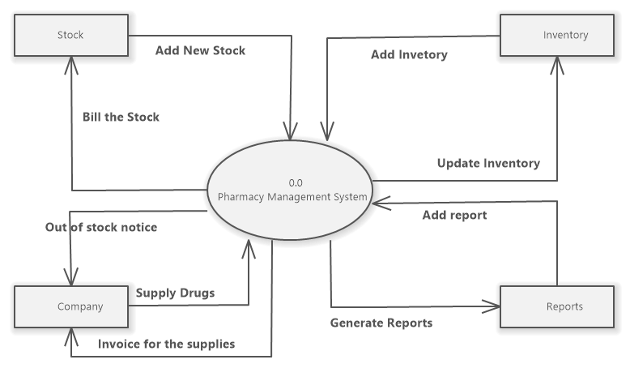

#### **Figure 2.0 Level 1 data flow diagram**

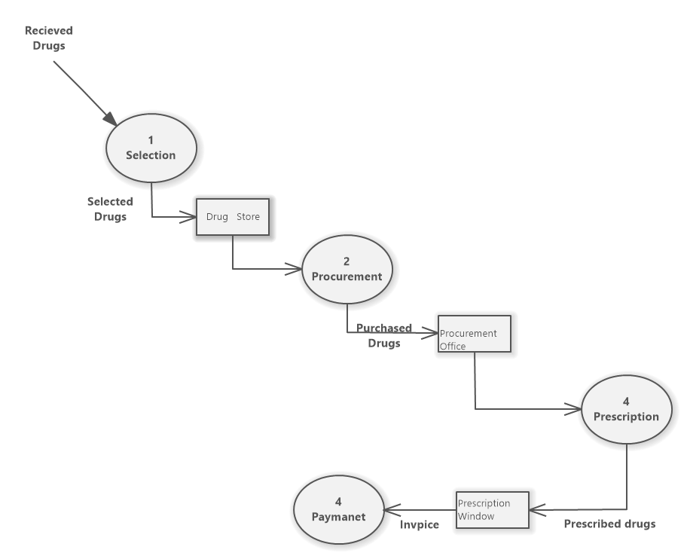

#### **Figure 3.0 Level 2 data flow diagram**

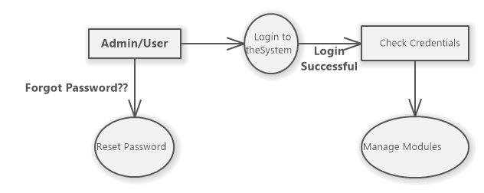

## **5.3 Requirements analysis**

This phase involved visiting the client company and interacting with the staff of the concerned department to try and come up with the system requirements and form a basis for our software development The system constraints and services were established in this stage and planning was underway basing on the fact gathered.

### **5.3.1 Hardware and Software Requirements**

During hardware evaluation it was found that the machines in use were not enough and also very slow to match the needs of the growing business. The following hardware was recommended to be purchased either to upgrade the existing machines or to install new machines in the system.

• Six computer sets (complete with keyboard, mouse and monitors)

• Pentium IV processor with 2.40HZ processing speed

• CD-ROM

• 256-512MBofRAM

• 80-12OGBharddisks

The computers were then networked with one of them acting as a central server along with other necessities like the photocopiers, UPS and also network cables. Software tools put in place included, MMySQL, NetBeans and windows 10 operating systems.

### **5.3.2 User and Security Requirements**

These basically included use of security passwords to prevent unauthorized persons from accessing the system as well as installation of antivirus programs like Avast to prevent viruses and worms.

Users were supported in antivirus ways by the system as defined during requirements analysis and so the system was able to:

• Update and delete records as required.

• Generate reports to be used by administrators for management purposes

• Give patients and staff details whenever needed.

### **5.3.3 Functional and Non-functional Requirements**

The system has been created to meet the following functional requirements:

Produce reports of all drugs purchased and received and sold in a given period of time

* Produce a list of all suppliers and customers and their details that have carried business within the organization.
* Monitor stock levels
* Search and query for data in the database

Non-functional requirements included:

* Data integrity through validation rules
* Efficient and ease usability of the system
* Controlled access to the system and determining who is responsible which type of data.

## **5.4 System and Software Design**

In this phase the requirements gathered in the analysis phase were divided into two

groups: software and hardware. The hardware required helped define the architecture of

the proposed system while the software design the fundamental abstractions and their

relationships-were defined1 According to the system in question, we stated our design

objectives as

• Flexibility

• Feasible

• Meet user requirements

• Efficient

The output of this stage was an architectural model consisting of the specifications of the components which describe what each component must do by specifying the interfaces of the components.

### **5.4.1 Physical System Design**

### **5.4.1.1 Entity Relationship Diagram**

This is part of the system development methodology that provides an understanding of logical data requirements of a system independent of the system’s organization and process. It presents a static review of relationships between different entities(Raghu, 2000). It is a conceptual data model that views the real world as entities and relationships and was originally proposed by (Peter, 1976):as a way to unify the network and relational database views. The ER model helped us to describe the data in terms of objectives and their relationships

hence we used it to develop an initial database design.

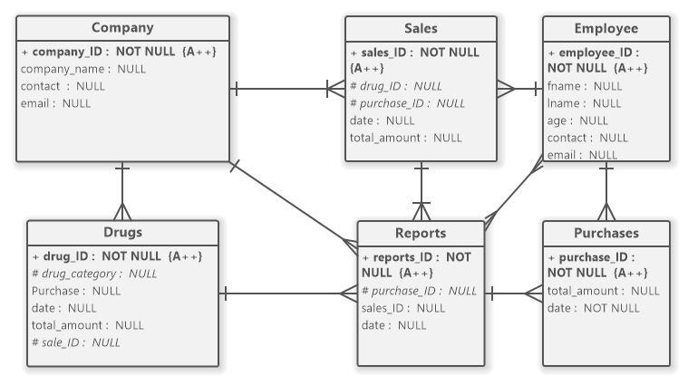

#### **Figure 5.0 Entity relationship diagram**

### **5.4.3 Logical Design**

Mapping tables

The user data in the database is represented as relations as seen in the entity relationship diagram. The columns of the table contain fields and rows of the table contain records for particular entities in the pharmacy environment.

**Company table**

|  |  |  |  |  |  |  |  |  |  |
| --- | --- | --- | --- | --- | --- | --- | --- | --- | --- |
| **#** |  | **Name** | **Type** | **Collation** | **Attributes** | **Null** | **Default** | **Comments** | **Extra** |
| 1 |  | **NAME** | varchar(50) | latin1_swedish_ci |  | No | *None* |  |  |
| 2 |  | **ADDRESS** | varchar(50) | latin1_swedish_ci |  | No | *None* |  |  |
| 3 |  | **PHONE** | varchar(20) | latin1_swedish_ci |  | No | *None* |  |  |

**Sales table**

|  |  |  |  |  |  |  |  |  |
| --- | --- | --- | --- | --- | --- | --- | --- | --- |
| **#** | **Name** | **Type** | **Collation** | **Attributes** | **Null** | **Default** | **Comments** | **Extra** |
| 1 | **BARCODE** | varchar(20) | latin1_swedish_ci |  | No | *None* |  |  |
| 2 | **NAME** | varchar(50) | latin1_swedish_ci |  | No | *None* |  |  |
| 3 | **TYPE** | varchar(10) | latin1_swedish_ci |  | No | *None* |  |  |
| 4 | **DOSE** | varchar(10) | latin1_swedish_ci |  | No | *None* |  |  |
| 5 | **QUANTITY** | int(11) |  |  | No | *None* |  |  |
| 6 | **PRICE** | double |  |  | No | *None* |  |  |
| 7 | **AMOUNT** | double |  |  | No | *None* |  |  |
| 8 | **DATE** | varchar(15) | latin1_swedish_ci |  | No | *None* |  |  |

**Drugs table**

|  |  |  |  |  |  |  |  |  |
| --- | --- | --- | --- | --- | --- | --- | --- | --- |
| **#** | **Name** | **Type** | **Collation** | **Attributes** | **Null** | **Default** | **Comments** | **Extra** |
| 1 | **NAME** | varchar(50) | latin1_swedish_ci |  | No | *None* |  |  |
| 2 | **TYPE** | varchar(20) | latin1_swedish_ci |  | No | *None* |  |  |
| 3 | **BARCODE** | varchar(20) | latin1_swedish_ci |  | No | *None* |  |  |
| 4 | **DOSE** | varchar(10) | latin1_swedish_ci |  | No | *None* |  |  |
| 5 | **CODE** | varchar(10) | latin1_swedish_ci |  | No | *None* |  |  |
| 6 | **COST_PRICE** | double |  |  | No | *None* |  |  |
| 7 | **SELLING_PRICE** | double |  |  | No | *None* |  |  |
| 8 | **EXPIRY** | varchar(20) | latin1_swedish_ci |  | No | *None* |  |  |
| 9 | **COMPANY_NAME** | varchar(50) | latin1_swedish_ci |  | No | *None* |  |  |
| 10 | **PRODUCTION_DATE** | date |  |  | No | *None* |  |  |
| 11 | **EXPIRATION_DATE** | date |  |  | No | *None* |  |  |
| 12 | **PLACE** | varchar(20) | latin1_swedish_ci |  | No | *None* |  |  |
| 13 | **QUANTITY** | int(11) |  |  | No | *None* |  |  |

**Expiry table**

|  |  |  |  |  |  |  |  |  |
| --- | --- | --- | --- | --- | --- | --- | --- | --- |
| **#** | **Name** | **Type** | **Collation** | **Attributes** | **Null** | **Default** | **Comments** | **Extra** |
| 1 | **PRODUCT_NAME** | varchar(50) | latin1_swedish_ci |  | No | *None* |  |  |
| 2 | **PRODUCT_CODE** | varchar(20) | latin1_swedish_ci |  | No | *None* |  |  |
| 3 | **DATE_OF_EXPIRY** | varchar(10) | latin1_swedish_ci |  | No | *None* |  |  |
| 4 | **QUANTITY_REMAIN** | int(11) |  |  | No | *None* |  |  |

**Purchase table**

|  |  |  |  |  |  |  |  |  |
| --- | --- | --- | --- | --- | --- | --- | --- | --- |
| **#** | **Name** | **Type** | **Collation** | **Attributes** | **Null** | **Default** | **Comments** | **Extra** |
| 1 | **BARCODE** | varchar(20) | latin1_swedish_ci |  | No | *None* |  |  |
| 2 | **NAME** | varchar(50) | latin1_swedish_ci |  | No | *None* |  |  |
| 3 | **TYPE** | varchar(20) | latin1_swedish_ci |  | No | *None* |  |  |
| 4 | **COMPANY_NAME** | varchar(20) | latin1_swedish_ci |  | No | *None* |  |  |
| 5 | **QUANTITY** | int(11) |  |  | No | *None* |  |  |
| 6 | **PRICE** | double |  |  | No | *None* |  |  |
| 7 | **AMOUNT** | double |  |  | No | *None* |  |  |

**Login table**

|  |  |  |  |  |  |  |  |  |
| --- | --- | --- | --- | --- | --- | --- | --- | --- |
| **#** | **Name** | **Type** | **Collation** | **Attributes** | **Null** | **Default** | **Comments** | **Extra** |
| 1 | **NAME** | varchar(50) | latin1_swedish_ci |  | No | *None* |  |  |
| 2 | **TYPE** | varchar(20) | latin1_swedish_ci |  | No | *None* |  |  |
| 3 | **DATE** | varchar(20) | latin1_swedish_ci |  | No | *None* |  |  |
| 4 | **TIME** | varchar(20) | latin1_swedish_ci |  | No | *None* |  |  |

**Sales_history table**

|  |  |  |  |  |  |  |  |  |
| --- | --- | --- | --- | --- | --- | --- | --- | --- |
| **#** | **Name** | **Type** | **Collation** | **Attributes** | **Null** | **Default** | **Comments** | **Extra** |
| 1 | **USER_NAME** | varchar(20) | latin1_swedish_ci |  | No | *None* |  |  |
| 2 | **BARCODE** | varchar(20) | latin1_swedish_ci |  | No | *None* |  |  |
| 3 | **NAME** | varchar(50) | latin1_swedish_ci |  | No | *None* |  |  |
| 4 | **TYPE** | varchar(10) | latin1_swedish_ci |  | No | *None* |  |  |
| 5 | **DOSE** | varchar(10) | latin1_swedish_ci |  | No | *None* |  |  |
| 6 | **QUANTITY** | int(11) |  |  | No | *None* |  |  |
| 7 | **PRICE** | double |  |  | No | *None* |  |  |
| 8 | **AMOUNT** | double |  |  | No | *None* |  |  |
| 9 | **DATE** | varchar(15) | latin1_swedish_ci |  | No | *None* |  |  |
| 10 | **TIME** | varchar(20) | latin1_swedish_ci |  | No | *None* |  |  |

**Inbox table**

|  |  |  |  |  |  |  |  |  |
| --- | --- | --- | --- | --- | --- | --- | --- | --- |
| **#** | **Name** | **Type** | **Collation** | **Attributes** | **Null** | **Default** | **Comments** | **Extra** |
| 1 | **MESSAGE_FROM** | varchar(20) | latin1_swedish_ci |  | No | *None* |  |  |
| 2 | **MESSAGE_TO** | varchar(20) | latin1_swedish_ci |  | No | *None* |  |  |
| 3 | **MESSAGE_TEXT** | varchar(200) | latin1_swedish_ci |  | No | *None* |  |  |

**Users table**

|  |  |  |  |  |  |  |  |  |
| --- | --- | --- | --- | --- | --- | --- | --- | --- |
| **#** | **Name** | **Type** | **Collation** | **Attributes** | **Null** | **Default** | **Comments** | **Extra** |
| 1 | **ID** | int(11) |  |  | No | *None* |  |  |
| 2 | **NAME** | varchar(50) | latin1_swedish_ci |  | No | *None* |  |  |
| 3 | **DOB** | varchar(20) | latin1_swedish_ci |  | No | *None* |  |  |
| 4 | **ADDRESS** | varchar(100) | latin1_swedish_ci |  | No | *None* |  |  |
| 5 | **PHONE** | varchar(20) | latin1_swedish_ci |  | No | *None* |  |  |
| 6 | **SALARY** | double |  |  | No | *None* |  |  |
| 7 | **PASSWORD** | varchar(20) | latin1_swedish_ci |  | No | *None* |  |  |

## **5.5 Conclusion**

In general, the methods used in collecting the data required were quite good and substantial information was obtained. This data from the respondents was of great importance in coming up with the system requirements both functional and non—functional and also the user, hardware and software requirement.

# CHAPTER SIX: SYSTEM DESIGN

## **6.1 Analysis**

This chapter explains how the system was developed relative to the user requirements. The system has been developed with scalability in mind and can be developed further to enhance performance and meet user needs as they arise. This gives space for future expansion inline with the growth of the pharmacy to meet outer competition and ensure reliable services.

## **6.2 Presentation of the System**

Below are some of the interfaces of the system.

**6.2.1 Login Screen**

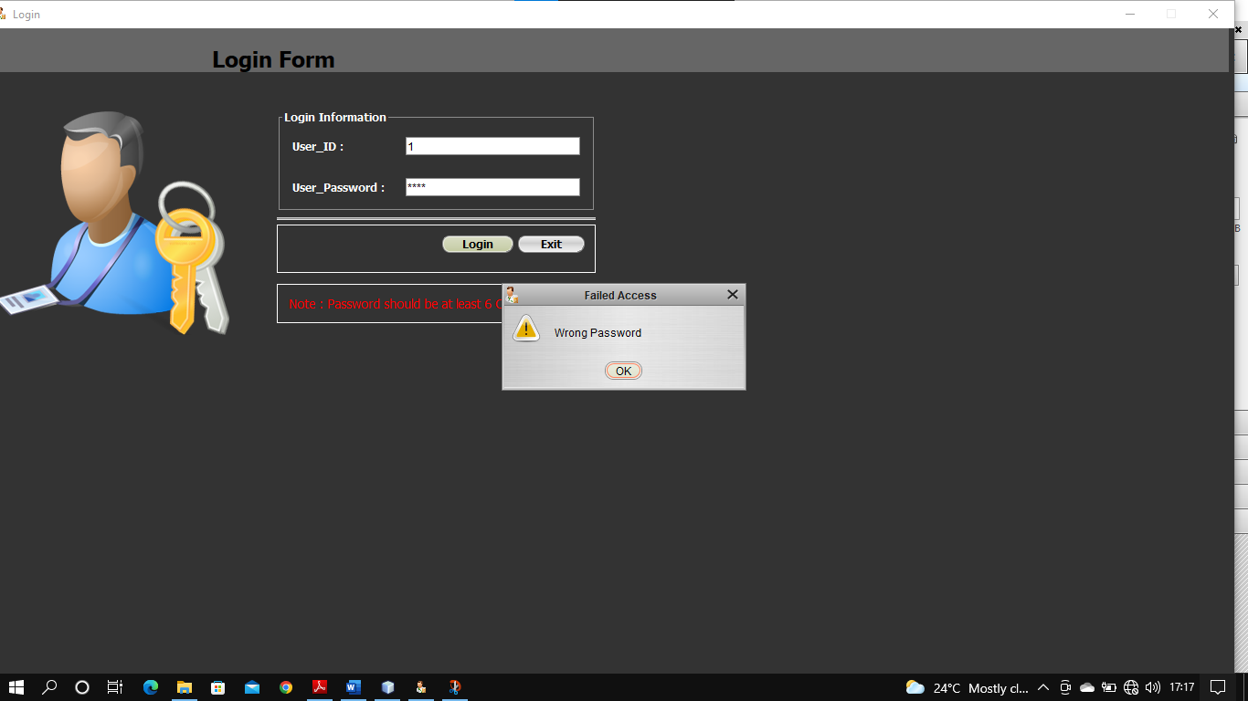

This screen is basically used for authentication purposes. The user is required to prove his/her authenticity through a userame and a password as shown above. If the wrong password is entered then access to the system is denied and the user is propmted to enter the correct username and password.

## **6.2.2 Database**

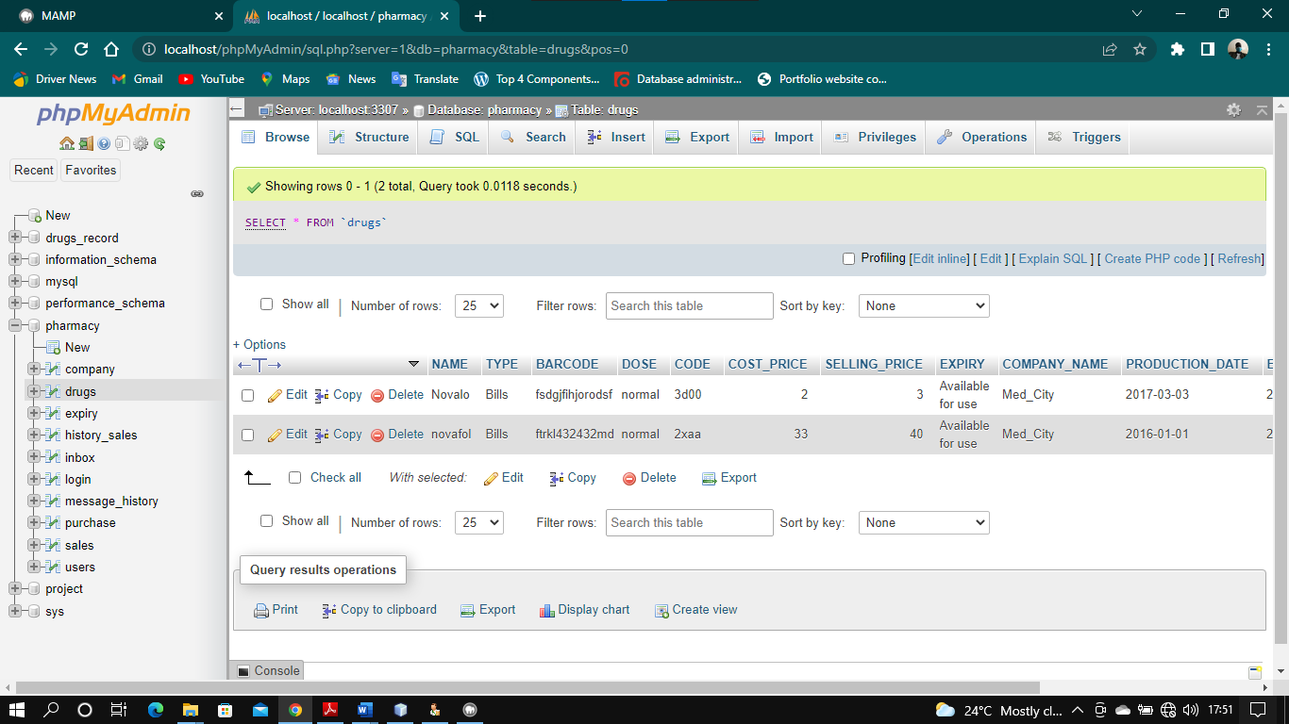

This form acts as the central repository to store all system information, by using this form, the use of papers and manual storage was eliminated. It is one of the ways through which the current system achieves security.

## **6.3 Evaluation of alternatives and strategies**

Due to the weaknesses of the existing system such as insecurity, time consuming, user unfriendliness, file storage system which makes the system to be inefficient and ineffective to the university voting process. The current system is an improvement through modification of the existing system through the use of unique voters I.D, use of modern database to replace the file storage system and designing a full secure - interactive web-based system. The current system automates operations unlike the existing system.

# CHAPTER SEVEN: SYSTEMS IMPLEMENTATION

## **7.1 Systems implementation**

This section describes and explores the tools used to implement the graphical user interface, the database and the business logic. The system was implemented on a Microsoft windows platform using MAMP server that contains Apache web server and MySQL Database server and NetBeans for val idating the entry forms.

## **7.2 Systems implementation**

### **7.2.1 Systems implementation**

This involved testing the entire system by the system developer and testing team to determine if the system met its requirements. The usability requirement was achieved through the systems response to user’s/admin’s interactions. This was majorly done to identify errors in the system.

### **7.2.2 Unit testing**

Unit testing was aimed at determining whether the individual components of the system meet their intended functionalities.

### **7.2.3 Integration testing**

This testing combined the different individual modules and tested it as a group, it was one after each of the different modules was tested individually and its function was to verify performance, functionality and reliability requirements of the system. This was done on a complete integrated system to evaluate the system’s compliance with its specified requirements.

### **7.2.3 Acceptance testing**

Acceptance testing was done to ensure that the system performs all functions and fulfills user’s requirements. This testing was done after a number of modules were integrated and formulated a full component. This helped voters to evaluate the system as per requirements.

### **7.2.4 Acceptance testing**

To ensure system validation, tests were carried out on the system to verify that the system met the specified user requirements. The system was presented to the users so as to get feedback about the system performance as to whether the system met their requirements.

The authentication procedure that was implemented in this system could only allow the registered users to access the system after receiving passwords in their inboxes as a mandatory else an alert message was prompted to unauthorized users as illustrated below;



# CHAPTER EIGHT: DISCUSSIONS, CONCLUSIONS AND RECOMMENDATIONS

## **8.1 Introduction**

This chapter highlights on the discussion of recommendations and conclusion drawn as a

result of completing this project.

## **8.2 Discussions**

After the research it was established that the current manual system had various shortcomings. There were few computers scattered over the organization premises. These machines were slow and inefficient. The- new system was implemented with six new computer sets with improved speed and relatively larger external memory. This eliminated the data storage problems and the time wasted to retrieve data as the computers were more reliable. The computers within the premises were also networked allowing easier sharing of information between various departments. The new system was designed with various interfaces which allowed for easy and controlled data validation and this eliminated the greatest setback of uncontrolled data access that the organization was facing, Data replication and integrity was greatly improved as it was easier to enter new records, delete redundant records and validate data stored. This in turn ensured greater productivity from the staff as little time was used to manipulate rccords. Reports helped the administration to make informed decision and planning strategies, placing the organization in a better competitive position.

## **8.3 Recommendations**

* We recommended before the application is put into full use it should be further tested in sample field to eliminate any bugs that may not have been identified at the time of development.
* Password levels may be increased to higher levels depending on the confidentiality of the stored data. The current system password is basically low level.
* If opportunity aIllows, we hope that the features that have not been implemented in this application but were originally desired features will be implemented in order to improve on the efficiency, reliability and user friendliness of this system. These features include• external networking (the internet) which will allow automatic placement orders form the suppliers.
* We recommend the appointment of a systems administrator who will be in charge of maintaining the system and also user training on the use of the new system.

# References

JeonSoft Corporation. (2014). *JeonSoft Corporation*. Retrieved from jeonsoft.com: https://jeonsoft.com

MacCallum, R. C. (1993). Sample size. *British medical jorunal*, 1181-1184.

McPherson, M., Counahan, M., & Julie, L. H. (2015). Responding to Typhoon Haiyan in the Philippines. *Western Pacific Surveillance and Response Journal*.

Muallem, A. Y., Assaf, A. R., & Dogother, A. M. (2015). *A pharmacy management system in saidi arabia: a case study,Studies in health technology and informatics.* Saudi Arabia.

# APPENDIX A: Pharmacy owner sample Questionnaire

1. What kind of pharmacy are you?

* Private
* Government

1. Do you face competition from other pharmacies?

* Yes
* No

# APPENDIX B: Customers Questionnaire

1. How long does it take to be attended to in the pharmacy?

* 2-5 Minutes
* 5-10 Minutes
* 10- 20 Minutes
* More than 20 Minutes

1. Skill and competency of the pharmacy staff

* Excellent
* Good
* Average
* Poor

1. Communication and detailing skills of the pharmacy staff

* Excellent
* Good
* Average
* Poor

1. Friendliness and courtesy of the staff

* Excellent
* Good
* Average
* Poor

# APPENDIX C: Staff Questionnaire

1. How many hours are you expected to be at the pharmacy in a typical working day?

* 2-4 hours
* 4-6 hours
* 6-8 hours
* 8-10 hours

1. How are the top stakeholders treating you in the pharmacy?

* Good
* Fair
* Harsh

1. Are the challenges presented to the stakeholders addressed?

* Yes
* No

# APPENDIX D: Sample pharmacy owner Interview Questions

1. What are the challenges that you are facing in your pharmacy?
2. What do you think could be incorporated into the current systems to make them effective?

# **APPENDIX E: Sample Customer Interview** **Question**s

1. How often do you visit the pharmacy?
2. How were you handled during your previous visit?

# APPENDIX F: Sample Staff Interview Questions

1. What challenges do you face when delivering the services?
2. How long does it take to attend to one customer?

# GANTT CHART

|  |  |  |  |  |  |  |  |  |  |
| --- | --- | --- | --- | --- | --- | --- | --- | --- | --- |
| **WEEKS**  **Deliverables** | WEEK 5 | WEEK 6 | WEEK 7 | WEEK 8 | WEEK 9 | WEEK 10 | WEEK 11 | WEEK  12 | WEEK 13 |
| Formulating Problem Statement and objectives |  |  |  |  |  |  |  |  |  |
| Conducting Literature Review |  |  |  |  |  |  |  |  |  |
| Framing the Objectives and Background Study |  |  |  |  |  |  |  |  |  |
| Documenting Methodology |  |  |  |  |  |  |  |  |  |
| Carrying out System Analysis |  |  |  |  |  |  |  |  |  |
| Compiling the project documentation |  |  |  |  |  |  |  |  |  |
|  |  |  |  |  |  |  |  |  |  |
|  |  |  |  |  |  |  |  |  |  |